**Dress and Play Customer Satisfaction Survey**

Tell us everything! Please take a few minutes to share your thoughts about how we can improve our products and services.

1. What is your age?
   1. Under 18
   2. 18–25
   3. 26–35
   4. 36–45
   5. 46–55
   6. 56–65
   7. 65+
   8. Prefer not to answer
   9. Other:
2. What gender do you identify as?
   1. Female
   2. Male
   3. Non-binary
   4. Transgender
   5. Prefer not to answer
   6. Other:
3. How many children do you have?
   1. 1
   2. 2
   3. 3
   4. 4
   5. 5
   6. Prefer not to answer
   7. Other:
4. Please rate your level of satisfaction with the:
   1. Quality of our products

Very dissatisfied Dissatisfied Neutral Satisfied Very Satisfied

* 1. Availability of the products you're looking for

Very dissatisfied Dissatisfied Neutral Satisfied Very Satisfied

* 1. Value of our products

Very dissatisfied Dissatisfied Neutral Satisfied Very Satisfied

* 1. Ease of navigation on our website

Very dissatisfied Dissatisfied Neutral Satisfied Very Satisfied

* 1. Ease of the checkout process on our website

Very dissatisfied Dissatisfied Neutral Satisfied Very Satisfied

1. How likely is it that you would recommend Dress and Play to a friend?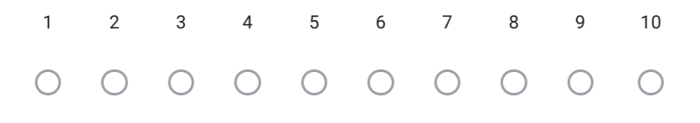

Not likely Very likely

1. What improvements can we make to better meet your needs?
2. Do you have any additional comments or feedback for us?